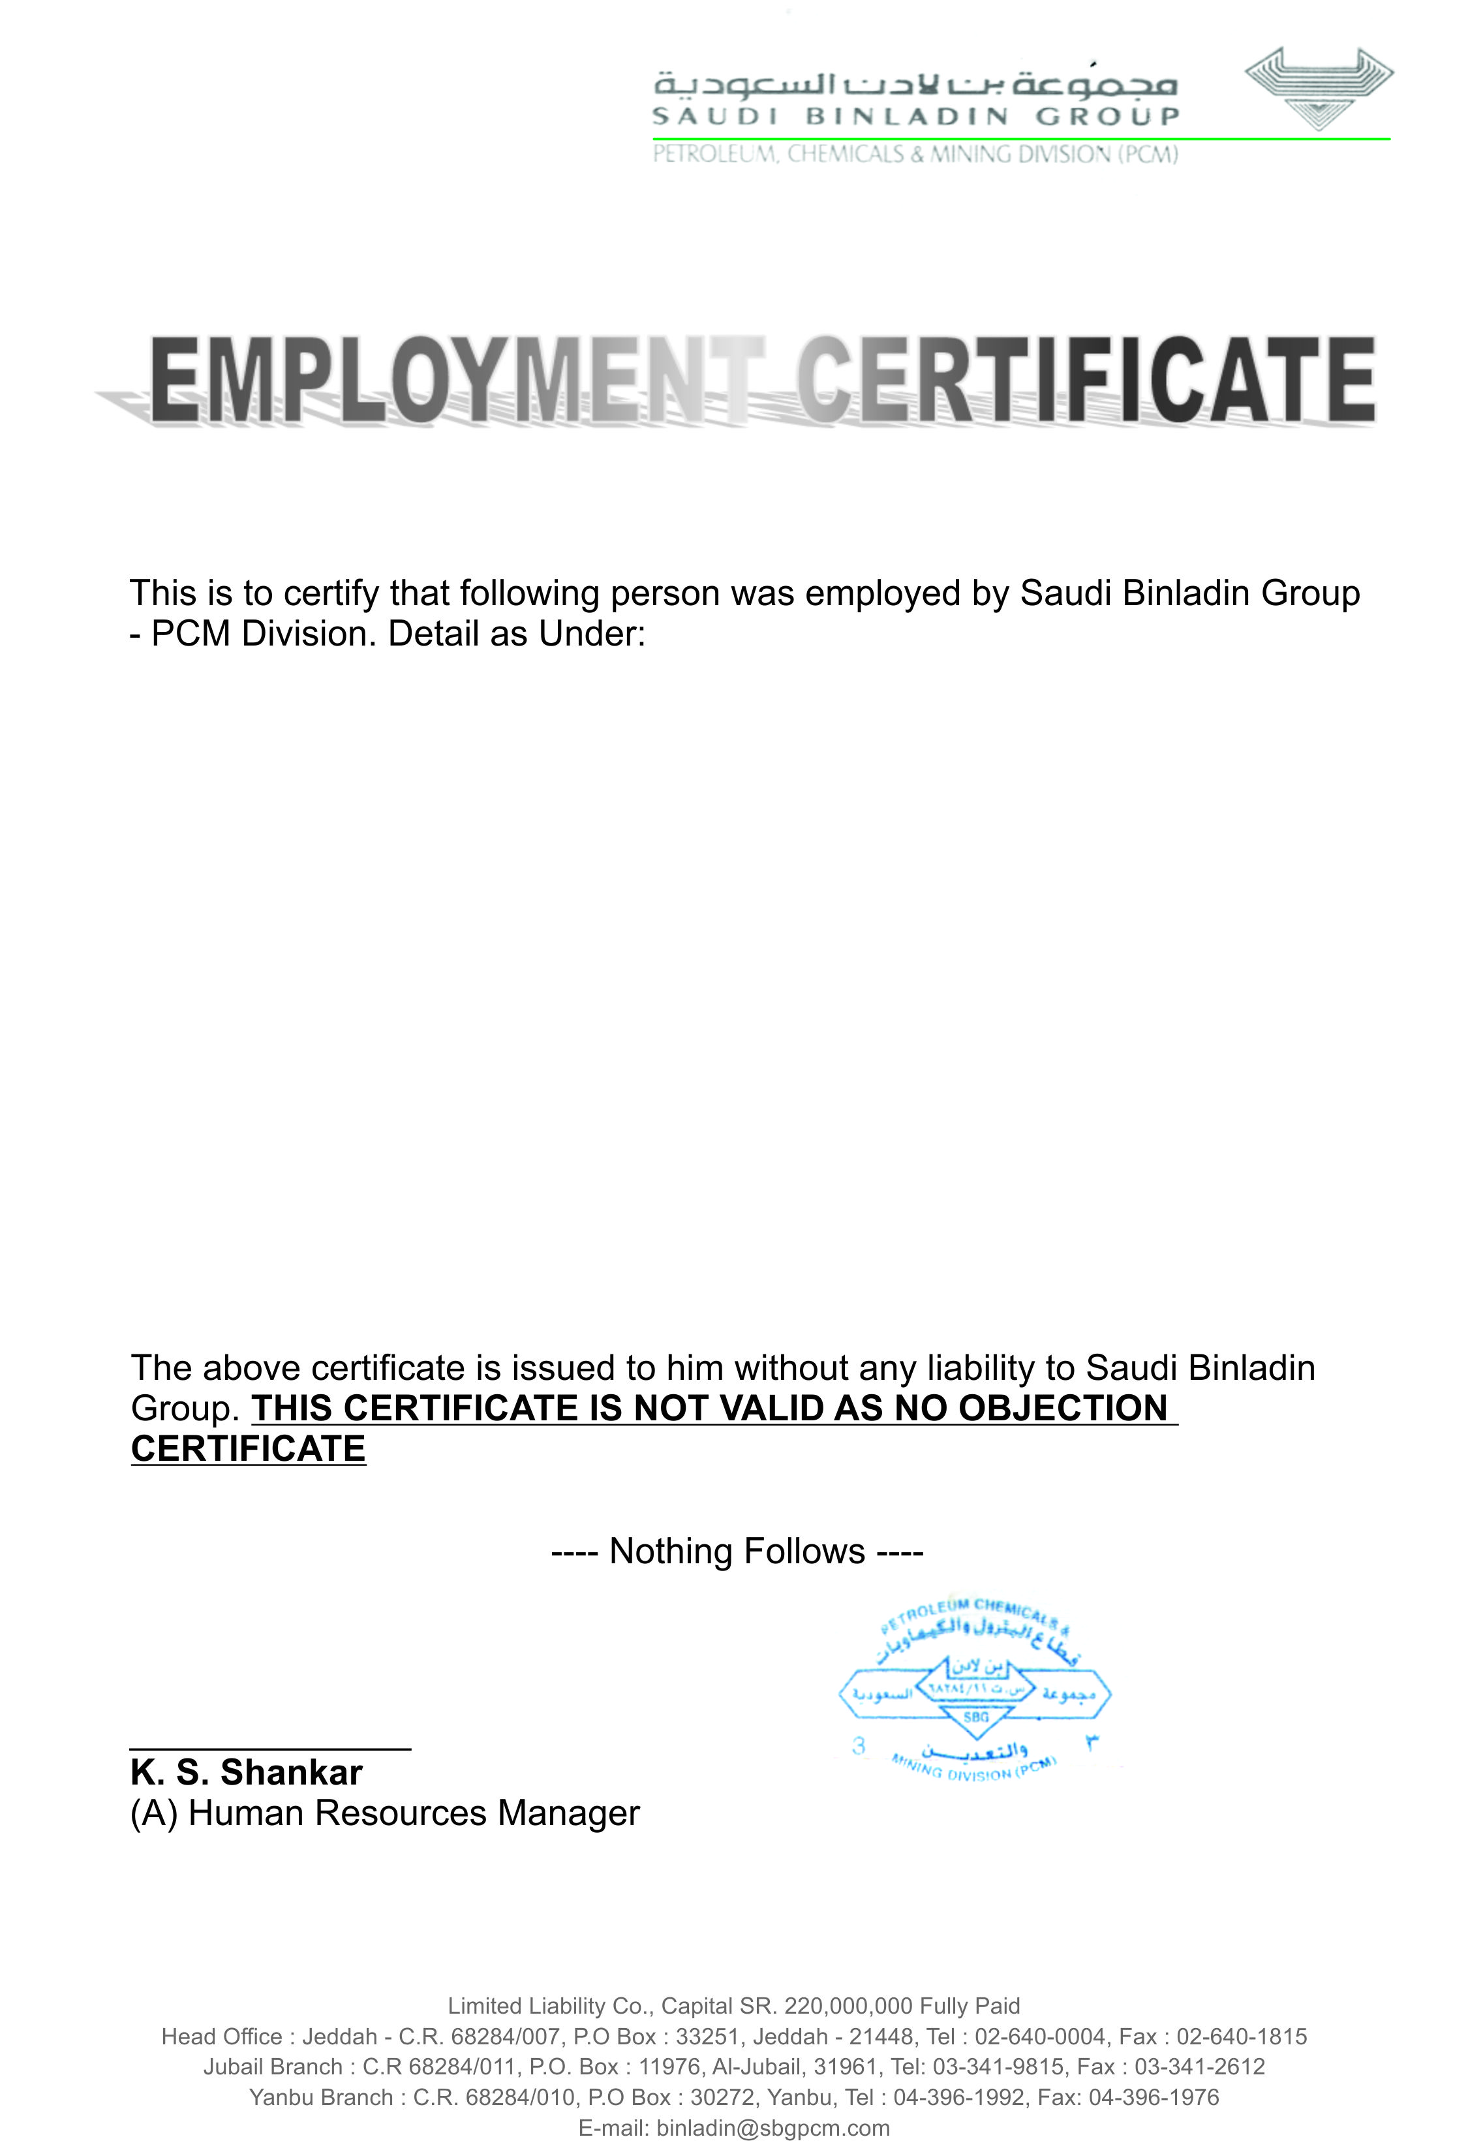

|  |  |  |
| --- | --- | --- |
| Name  Nationality  Passport No.  Employee No.  Last Position  Employment Period | :  :  :  :  :  : | <Name> <fname>  Pakistani  <Passport>  S04-2874  <Designation>  <From> TO <To> |

